Navigating to Watts College Catalog

Option I: Use this link to navigate directly to the Watts College Catalog.

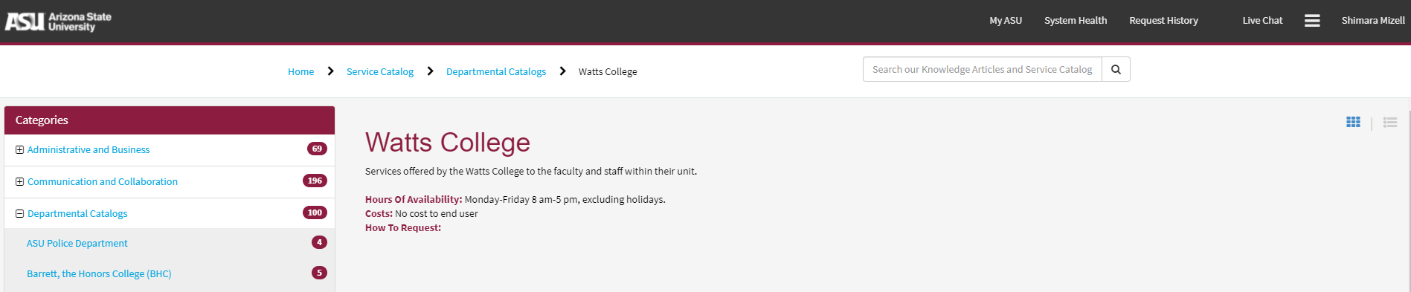

Option II: Under Departmental Catalogs, click on Watts College.

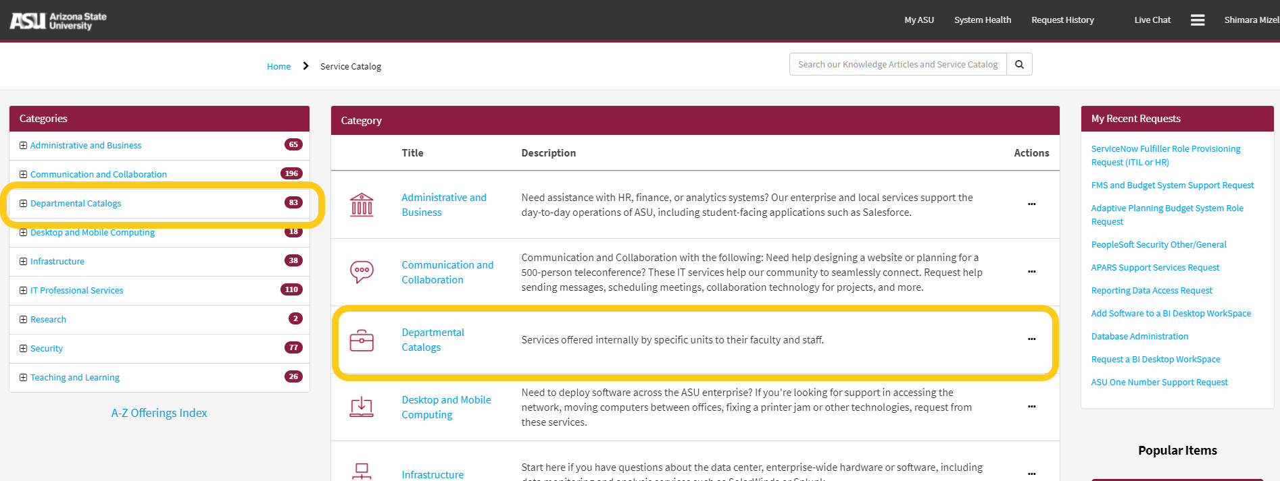

Option III: Type Watts into any search bar within ServiceNow to view a list of available forms.

